Evalutate mabs prealignment

In order to evaluate which kind of rigid alignment works better for MABS prealignment we quantify the distance between landmarks. For this purpose five anatomical points have been choosed. They are:

- Chin (chin)
- Right condyloid process (mand_r)
- Left condyloid process (mand_l)
- Odontoid process (odont_proc)
- Occopital bone (occ_bone)
The landmarks have been clicked according to the following guidelines:

Chin: in axial view, on the last slice in cranio-caudal direction where the chin is well visible, click in the middle of the mandible bone.

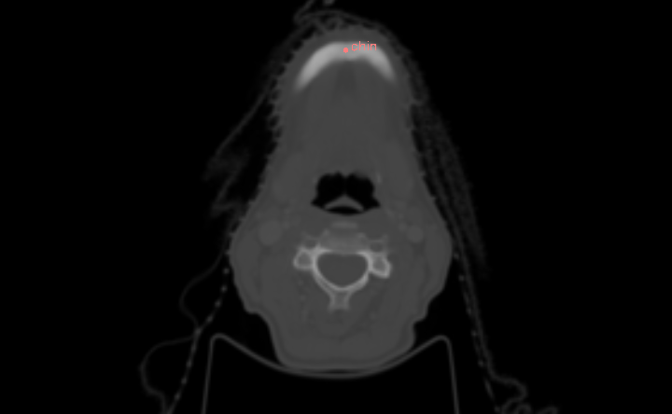

mand_r and mand_l: in axial view, on the first slice in cranio-caudal direction where the right/left condyloid process is well visible, click in the middle of the condyle.
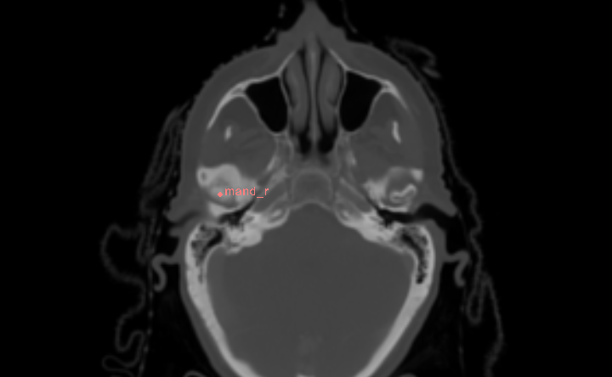
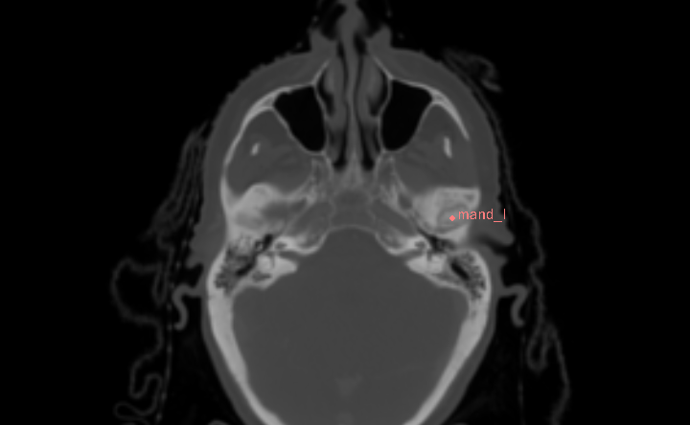

odont_proc: in axial view, on the first slice in cranio-caudal direction where the odontoid process is well visible, click in the middle of the dens.

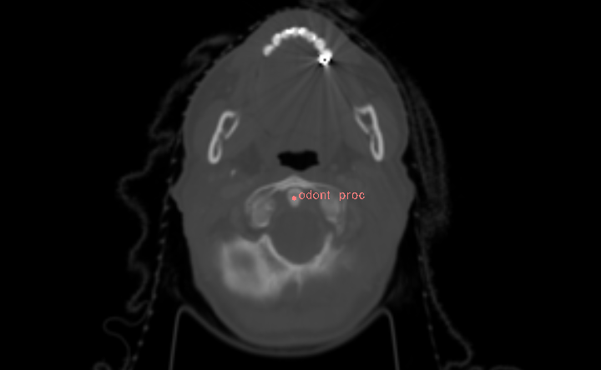

occ_bone: in sagittal view, on the same slice where the chin landmark lies, click the occipital bone as shown below.

